1. Label the parts of the mitochondrion in the diagram below.
2. Diagram the pathways involved in the aerobic breakdown of glucose to generate ATP (at the level of detail we covered in class), and indicate where they take place in the diagram below.
Cell Membrane

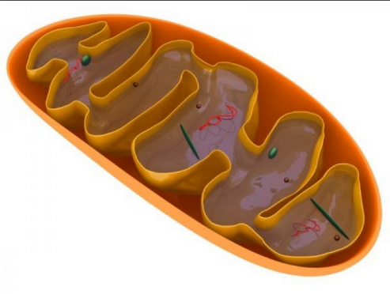

3. Diagram how lactic acid is produced in the cell, and explain when/why it happens.

4. What is the name of the process by which ADP is converted to ATP during aerobic respiration in the mitochondria? Where does the energy used in the process come from?

5. What is the name of the process by which H+ ions are moved from the matrix to the intermembrane space and then back to the matrix again by going through ATP Synthase?

6. Complete the following chemical equation of cellular respiration. After completing the equation, label the components that are oxidized and the ones that are reduced.

C₆H₁₂O₆ + 6 O₂ _________ + __________ + __________

7. During the aerobic breakdown of glucose, where is NADH produced? FADH₂? CO₂? ATP?

